SWEN303

# Team 27 Group Project

**Hannah Clayton**

**300351172**

**Krishan Gordhan**

**300334314**

**Margaret Hewitt**

**300338376**

**Zequn Jiang**

**300325346**

*Video Link*

# Part 1. Requirements (10 pages)

### Overview

With access to a limited amount of user data sourced from Victorias’s Annual Report (2011, 2012, 2013) we could make inferences regarding a Victoria student’s gender, age, and level of study. Majority students are undergraduate females, aged 20-24. The retention rate at Victoria is ~85% so the system predominantly hosts users who are familiar with the universities LMS.

It’s safe to assume that first-year students straight from highschool are familiar with a LMS from school.

//will be roughly 2 pages

//Present a collated set of requirements according to Part 2 (the model) of the report for A2

The requirements of the system in terms of meeting students needs?

//the model from part 2 details the scenarios

//purpose of the LMS contextually

//why we did what we did

//You may use the extra page to extend one of the sections in that report (Overview, Personas, Scenarios).

//use case diagram

### 

### Personas

**Persona 1: Brendon**

//undergrad student

Brendon is a 21-year-old first-year student at Victoria University studying Information Systems. He’s fresh out of high school, so is familiar with the LMS education style. Brendon is up to date with the latest web applications and is a harsh critic of the usability of a product. Brendon believes its important for a product to be simple and intuitive, . Once Brendon has applied himself to solving a problem he persevere until he’s finished. However Brendon leads a busy life so it’s important to him not to have dig for information regarding the key aspects of his courses. Brendon thrives when information is at his fingertips.

//TODO insert image

System goals = check this week’s uni commitments, doesn’t like a lot of information at once because he finds it overwhelming.

Activities:

Attitudes:

Aptitudes:

Skills:

Domain Knowledge:

System Knowledge:

Interaction:

Priorities:

Computer Self-efficacy:

Risk Tolerance:

Information Processing:

Tinkering:

**Persona 2: Shazza**

//student and tutor

Shazza is a 28-year-old second-year student and tutor at Vic studying accounting. Shazza meticulous and intelligent. Shazza doesn’t find new technology the easiest to understand, she likes processes that she’s familiar with. Because she’s a tutor and doesn’t go to lectures, it’s important for her to be able to access the latest course content without much hassle. Shazza’s LMS goal is to access information as efficiently as possible, she doesn’t want to waste time in tutorials having to dig through redundant information. She needs to be sure she can quickly access current course content for multiple courses and doesn’t want to miss anything important.

System goals = plan ahead, not miss any dates for their own course or the courses they tutor.

//TODO insert image

Activities:

Attitudes:

Aptitudes:

Skills:

Domain Knowledge:

System Knowledge:

Interaction:

Priorities:

Computer Self-efficacy:

Risk Tolerance:

Information Processing:

Tinkering:

**Persona 3: Chad**

//lecturer or course co-ordinator

Chad is a 53-year-old senior lecturer and course coordinator for English at the university. Chad has chosen to use a LMS as his main medium of course content delivery for his papers. Has chosen to live his adult life by himself so aged really well. He is a bit a narcissist and doesn’t like it when things don’t go his way, he gives up easily when it comes to new technology. Chad believes he was born in the wrong era to understand the new wave of technology but he tries to keep up with the kids. Chad doesn’t like when students ask him dumb questions, and in turn, won't seek help because he feels it makes him look dumb.

System goals = distribute information efficiently and notify the affected students

//TODO insert image

Activities:

Attitudes:

Aptitudes:

Skills:

Domain Knowledge:

System Knowledge:

Interaction:

Priorities:

Computer Self-efficacy:

Risk Tolerance:

Information Processing:

Tinkering:

**Persona 4:**

//office admin and/or support staff

System goals = handling enrollments, communicate course changes to lectures (room bookings for lecturers/tut, staff meetings, supply chain - course materials etc, formatting for dis )

**Persona 5:**

//PHD student who is international

System goals = get familiar with the new university, where to find course related vs. international program related help, and course content. Language translation.

Exchange student - check their on course at their home university

**Persona 5:**

//distance student

### 

### Scenarios

**Scenario 1: View Course Information (Student)**

Precondition: The user is authenticated

|  |  |
| --- | --- |
| **User Intention** | **System Responsibility** |
|  | Show courses |
| Choose course |  |
|  | Show course information |

**Scenario 2: View Course Content (Student)**

Precondition: The user is authenticated

|  |  |
| --- | --- |
| **User Intention** | **System Responsibility** |
|  | Show course content options |
| Choose option |  |
|  | Show course content |

**Scenario 3: Manage Course Signups (Student)**

Precondition: The user is authenticated

|  |  |
| --- | --- |
| **User Intention** | **System Responsibility** |
|  | Show course signup options |
| Choose course signup option |  |
|  | Show course signup option |
| Update option |  |
|  | Show changes |

Course signups options can be none or multiple from; Lab, team and tutorial signup.

**Scenario 4: Update Course Information (Lecturer)**

Precondition: The user is authenticated

|  |  |
| --- | --- |
| **User Intention** | **System Responsibility** |
| Update course information |  |
|  | Show confirmation |
|  | Show updated course information |
| Confirm |  |

**Scenario 5: Assignment Submission (Student)**

Precondition: The user is authenticated

|  |  |
| --- | --- |
| **User Intention** | **System Responsibility** |
| Upload submission |  |
|  | Show submission |
|  | Show confirmation |
| Confirm |  |
|  | Notify success |

**Scenario 6: Online Test (Student)**

Precondition: The user is authenticated

|  |  |
| --- | --- |
| **User Intention** | **System Responsibility** |
|  | Show test |
| Submit test |  |
|  | Show mark |

User has already selected the relevant test.

**Scenario 7: Forum (Student)**

Precondition: The user is authenticated

|  |  |
| --- | --- |
| **User Intention** | **System Responsibility** |
|  | Show forum |

The system knows the available forum options from the user being authenticated and the current course that they are viewing for the forum button to be available.

**Scenario 8: Mark Assignment (Tutor)**

Precondition: The user is authenticated

|  |  |
| --- | --- |
| **User Intention** | **System Responsibility** |
|  | Show assignment |
| Submit marking |  |
|  | Show confirmation |
| Confirm |  |
|  | Notify Success |

The user has already selected course and selected the assignment they wish to mark.

**Scenario 9: Notifications (Student)**

Precondition: The user is authenticated

|  |  |
| --- | --- |
| **User Intention** | **System Responsibility** |
|  | Show notifications |
| Select notification |  |
|  | Show notification details |

**Scenario 10: Manage Students (Lecturer)**

Precondition: The user is authenticated

|  |  |
| --- | --- |
| **User Intention** | **System Responsibility** |
|  | Show student requests |
| Update request status |  |
|  | Show updated request status |

A student can make a special admission to be accepted into a course or request an assignment extension, which the course lecturer updates.

**Scenario 11: Submission System Manager (Lecturer)**

Precondition: The user is authenticated

|  |  |
| --- | --- |
| **User Intention** | **System Responsibility** |
|  | Show due dates |
| Update due dates |  |
|  | Show confirmation |
| Confirm |  |

**Scenario 12: View Marks (Student)**

Precondition: The user is authenticated

|  |  |
| --- | --- |
| **User Intention** | **System Responsibility** |
|  | Show Marks |

Use can only navigate to marks page from specific course view. From there they can change the course.

**Scenario 13: Authenticate (Student)**

|  |  |
| --- | --- |
| **User Intention** | **System Responsibility** |
| Identify self |  |
|  | Verify Identity |

Postcondition: User is authenticated

**Scenario 14: Submission System View (Tutor)**

Precondition: The user is authenticated

|  |  |
| --- | --- |
| **User Intention** | **System Responsibility** |
|  | Show allocated assignments |
| Choose assignment to mark |  |
|  | Show assignment |

**Scenario 15: Help and Tutorials (Public)**

|  |  |
| --- | --- |
| **User Intention** | **System Responsibility** |
|  | Show help and tutorials |

Help and tutorials is filterable from within the webpage

**Scenario 16: Timetable (Student)**

Precondition: The user is authenticated

|  |  |
| --- | --- |
| **User Intention** | **System Responsibility** |
|  | Show timetable |

The system automatically generates the most up to date timetable

**Scenario 17: Manage Assignments (Lecturer)**

Precondition: The user is authenticated

|  |  |
| --- | --- |
| **User Intention** | **System Responsibility** |
|  | Show assignments |
| Update assignments |  |
|  | Show confirmation |
| Confirm |  |

**Scenario 18: Report Problem (Student)**

Precondition: The user is authenticated

|  |  |
| --- | --- |
| **User Intention** | **System Responsibility** |
| Write detail about problem |  |
| Submit |  |
|  | Show confirmation |
| Confirm |  |

The user has already selected the type of problem to report; bug or course content issue.

# Part 2. Design (19 pages)

### Overview (1-2)

**//TODO last**

**//overview of the LMS design - textual or diagrams**

**//i.e. Why we chose to design the LMS the way we did**

**//this can be linked back to the requirements in part 1**

**//overview mentions all the most important pages/screens and their content**

// Rough intro/Starting point for this section

The first step to redesigning a learning management system was to identify the users their requirements. We did this by creating Personas and establishing scenarios in which the personas would carry out a specific task. Brainstorming these scenarios as a group we were able formulate the main requirements of the website.

### The second step was to build key features of the learning management system that would meet the identified requirements of the primary persona and optomise the interaction between the system and the personas.

### Design (15-16)

**//present features of your design in order of importance**

**//one screen per page**

### 1. Homepage Design

The homepage is the first object that the user will see within the site. It is where users eyes are drawn too before anything else. We made this primary window the main starting point for the website, and the users needs should be found here.

We went for a multi-paned design, this was to split up the core features on the home page without the user having to scroll down or change the focus of the page. We used multi-paned as the things the user will be looking at are related. These will not be tabbed or stacked because we think they are all equally necessary and that we can fit in all the information without changing the display. We did not want to include any unnecessary windows.

The three panes will contain; Your current courses, your notifications and your schedule. The main goal we found our personas wanting for the site was to access their courses. So we put this on the main page as one of the panes, this lists all their courses and allows them to access the course page. Next the notifications, this will tell you if you have upcoming deadlines as well as important updates the lecturers think users should know or system admins think users should know. This can be marks are released, guest lecturers, down time of the system etc. Finally we have the schedule pane, this should show the upcoming days class and lab schedule as well as the ability to view what is due in the upcoming days.

### 1. Homepage Design (Michael edit)

The homepage is the most important feature of our website it has to be clean and easy to navigate, the content it provides is kept above the fold so the user sees it on first glance. At that first glance the user is given information about Current Course, Notifications & Schedule which are the three key components we identified in our user research.

To keep the information in the key components above the fold, we designed a horizontal multi-panel which has Current Courses on the left, Notifications in the middle and Schedule on the right, our research showed that accessing Current Courses was the primary goal of the user which is reflected in the primary persona Brendon so we placed this component where the user’s eyes will first look.

Each of these components in the multi-pane design will have all their key navigational paths confined within this is to avoid having pop-out menus that would distract/delay the user. The links within each pane:

* Current Courses will display links to each course.
* Notifications will display links to deadlines, course updates & any important changes
* Schedule will provide their schedule.

The overall design of the homepage provides the users a quick, efficient navigational experience which will ensure they get to their end goal in the least amount of time and effort.

//Placeholder

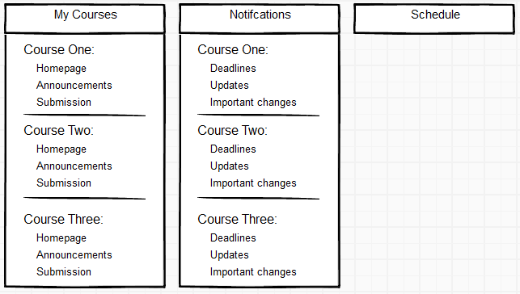

### 2. Navigation Menu Bar

The second point that the user looks at when accessing the site is a menu bar. We have our navigation menu at the top of the site. This navigation menu bar should be the main point of navigation through the site. We made this consistent throughout the site. If this is the main navigation we do not want this changing as people use the site.

We want each navigation menu to highlight as the user goes over them to show the selection. This gives feedback to the user to ensure they feel they are in control and have direct manipulation of this menu.

As each student has different courses they are enrolled in this menu can not be the same for each student. We wanted to keep it mostly the same so we designed a drop down for ‘My Courses’. This will list the courses that the user is assigned with. This allows us to keep the main navigation bar consistent through the users and site, but will display different information for the drop down of the courses. From this drop down the user can select the course and go to the relevant course page. We originally planned to have another menu from the course drop down so the user could go to the relevant page faster, but have found that cascading menus are not always easy to control.

For our menu although we know that icons help users recognise and navigate menus faster, we did not think we had enough items on the menu to justify using icons to save space. We preferred to leave the menu as names and help facilitate the pedagogic value of it.

### 2. Navigation Menu Bar(Michael edit)

One of the main persistent objects we wanted to incorporate into the design was a navigation menu bar which is located at the top of the page below the main header. The navigation menu bar would help orientate the user by providing clear navigational options while keeping them in full control with it’s fixed presence.

A design component we added to the menu bar was user feedback. When the user hovers their mouse cursor over the menu item it gives feedback that the item is clickable by highlighting that item with a coloured shade.

The main requirements for this navigational menu bar was to have a way for the user to always be able to get back to their homepage from anywhere on the website. We added a “My LMS” pathway to the bar to give the user this control.

The secondary requirement of the navigational menu bar was to have a personalised drop down menu that would allow the user to see their specific courses and navigate to that course homepage. Our research showed that users prefer using navigation menu bars to traverse their favourite websites over other methods.

The overall goal of the navigation Menu bar is to allow for quick and easy flow through the learning management system which we have achieved with this design.

### 

### 3. Side Menu Bar for Course Pages

(Title too wordy, I need to fix)

For each course we wanted to have a consistent menu users could navigate the course page with. This being a menu on the side of the primary window. Each course and lecturer would want different items displayed on the menu so the contents of the menu will not be consistent.

This side menu will have the same highlights as the top navigation menu. This is to ensure that the site feels consistent and does not feel like it is a seperate site.

The content on this side bar will have some options which are required by the site to be displayed this is to ensure that the course can function. This will be things such as, Course Homepage, lecture notes, lecture videos etc.

For the students they would not be able to see all the side menu options and pages, they will be hidden from the menu. For the admins of the course (lecturers, tutors) will be able to see all the options, but the options that are not displayed to the student will have a different colour as well as a tick box next to them that is empty. This is to ensure that there is no mistake on if the menu item is accessible. EIther through the user being colour blind or not picking up the colour difference.

The side menu will also not allow the page to be enabled if a page does not exist. This is to ensure the non admin users do not access a page that they’re not supposed to do.

### 4. Schedule and Calendar System

One of the major panes on the home page is the Schedule and Calendar system, it also has its own separate page that can be accessed from this home page and the navigation menu.

On the calendar page it will have a primary window as well as a secondary window on the side. The primary window will have the current set scale of time, with this changeable with a toolbar on top of the primary window. This toolbar allowing you to change the time, from the current day, to week to a monthly calendar. The toolbar also has the ability to add new events. There will also be a secondary window which will display a full month calendar which will have highlights as well as small symbols to show that there are important events on that day. Below that there will be the events that are coming up, each with the symbol in the colour marked on the calendar for when it is due. Each event having its own unique symbol. It will also have a timer alongside the event which counts down when it is due, this will be in days when its larger than two days and in hours if less than that.

The calendar depending on your set scale of time will highlight the time/day that it is on, this will involve changing the colour as well as making that section is bolded, so that you can easily count and calculate your schedule for the upcoming days.

Creating a new event will have a drop down which allows you to assign the category to the event to give this symbol.

### 5. Discussion Page

Needs a more appropriate title.

One of the options from the courses sidebar, is the discussion page. This is a separate page and will have a multi paned window. With two major panes, the first pane will be the current discussion. With all the relevant messages. On the left there will be the list of discussions, there will be two major discussions.

One which is available to all users with access to the course, the second being available to only non admin users. This is to allow the students to have a discussion about the course if they do not think it is necessary for the admins to see this.

There will be the ability to create new discussions on the left pane if they think it is necessary. On the right pane there will be a toolbar at the bottom so that the user is able to add new messages to the discussion as well as search through this discussion. The user will also be able to have access to the e-mail of any members who have made a comment in the discussion. The reason for this is the discussion is public and users sometimes want more control on what content people see.

For the left pane with all the discussions it will list the most recent discussions at the top and will have a bolded edge bar of a different colour if its a discussion with topics you have not read. It will also push a discussion to the top if a new message is posted. This is so the user does not have to scroll all the way to the bottom to see all the active discussions. The user can also mark all messages in a discussion as read without reading it in case this notification that it is not read is in the way.

### 

### 

### 

### 6. Search Bar

On the top right of the navigation bar, there will be a search bar. The location of this is to ensure its consistent with what other websites use making it faster and easier for the users to find.

This search bar shown with the icon of a magnifying glass as well as the text “Search” in the default search box. This is to allow users who are used to searching to see this icon and immediately identify that this is a search bar as well as users who are not familiar with it can see what it is.

When the search bar is selected it will change tone as well as the cursor for text will be displayed. The user can than push the icon to search or can push enter as a hotkey.

The search will not be for just this site but will be for the entire university network, for example with victoria university, this would search Victoria, ECS, SMS etc. This is to help users find the resources they need. They only need to go to this one location to find what they need, they do not need to go to every website and look around for what they want. This will create a more consistent experience as well as the user feeling like they have direct control of what they’re accessing.

### 

### 

### 

### 

### 

### 

### 

### 

### 

### 7. Language Change

In the top right in the header there will be a drop down menu. This drop down menu will display the current language with a flag representing it as well as the name of the language. The drop down will have the list of languages, with the name of the language displayed in that language. This list will be alphabetical in relation to the current language. An icon of the a flag representing the language will be next to each choice on the list.

When an option is selected all the system options will change to the language that is chosen. This means international students can navigate these menus without having to use a translation application and removes a step so that the user can work more efficiently.

This language option will save for the users account. This is so the user does not have to change the language each time they use the website. This is to ensure the user feels more in control and the stability of the website.

This feature is important for websites as a lot of universities have high number of international students. For victoria university it has nearly 15% of its students being international. Which is a possible 15% of users of this system that require the assistance of this drop down menu and the usability it provides.

### 

### 

### 

### 

### 

### 

### 

### 

### 

### 

### 8. Notifications Centre

One of the main panes on the homepage will be notifications. This will also have its own page accessible either through the home page or the navigation menu at the top.

This notification page will be a single pane design, with a list of all the notifications. Each notification will have a symbol and weight assigned to it. These symbols mirroring the calendars if it is relevant. These notifications weights will also have a colour to these symbols to ensure proper priority is attached to them.

At the top of the panel will be a system where the user can filter and search for notifications. Notifications are default sorted by date and will be greyed out if the date is passed the notifications due date. The filter system can sort out all the non essential notifications.

The notifications can be assigned by users through the calendar system or it can be assigned by the admins of the course and pushed to the course. Things such as assignments or guest lecturers or cancelled class all with their own weight to this notification system.

The user can also mark notifications and delete them as well as mark the notification as read so that they can be filtered out better. The user can also mark a notification to raise importance or notify the user with an email at a certain time period.

### 

### 

### 9. Admin Edit

If a user is the admin for a course and the user access that courses page, they will see a button in the top right of the screen which is admin mode or admin edit. If they do not push this button they will access this page as a normal user.

When the admin edit mode is enabled the user can then enable and disable pages for the course. As well as edit content on the course home page and course content page. When the user visits a specific page such as Assignments or lecture notes the user can edit the content on this page as well as make a new assignment or new lecture notes selection. The user can also create new pages on the side panel and add content to that page. This will be disabled by default and not showing on the side menu till the admin confirms that the page is right.

This admin edit mode also gives the user access to the submission system where they can see all the students enrolled in the courses submissions so the user can download the submitted files if it is appropriate or assign marks and comments on the marks to the user.

The admin also has access to some side menu items that are exclusive to the admins and are not possible to be enabled for students to be seen. These are menus involving student management, assigning new students or taking students down as well as reviewing marks and accessing the students information.

### 

### 

### 10. Web Forms for adding content

If the admin user wants to add content to one of the pages they will come across a web form to help with this. The web form will differ depending on the content they will try to add. The web form will open as a modal so that the user still feels connected to the page they are uploading to but still covering all the information that is needed.

The web forms will differ slightly depending on the content the admin wants to upload. For assignments the admin can upload a file, can set a name as well as can set a due date for this assignment. This can be pushed to the calendar if the admin wants. We did not want to force this as it came out that not everyone likes using this feature. The admin can set if this assignment should be completed as a group and if a file must be submitted for this assignment as well as the requirements for this file.

Depending on the form the user will be required to input certain info for this assignment, this is to ensure that the assignments across the courses are consistent and the user does not get confused with the variety of assignment formats.

The web forms for adding new lectures can also tie into previous lectures as not all lectures have their own set of notes as well as sometimes lectures taking longer or shorter than expected which means this linking of lecture notes can help with the flow of the notes.

The user also has the option to push a notification with an assigned symbol and weight for this so that the students of the course can get a notification there was an update instead of the lecturer needing to tell them. This can also have a due date pushed to the calendar so that the students do not need to each individually add the assignments to the calendar.

### 

### 

### 

### 

### 11. Header icon

Most websites have an icon in the top right corner of the header. This is to easily identify the website as well as if you push the icon it acts as a button to get to the homepage for the website.

Although we have a home button on the navigation bar this is a feature that is prevalent on so many websites that for users that are experienced with websites it is a usable feature.

### 

### 12. Radio Tick Boxes for enabling

For the course sidebar menu when it is admin edit mode the user needs a way to know if each page is enabled for the non admin users of the course. For this we put a square radio tick box next to each option on the menu, where the admin user can enable or disable these pages as they want. This tick box we found was the easiest way to show that this option was enabled without taking too much space on the UI.

Not all pages will have the option to change this, some of these tick boxes will be greyed out for a variety of reasons, either because this is a required page and can not be disabled or because the page is not complete enough to be enabled. For either reason the user will be able to hover over the greyed out tick box and see this reason.

### 

### 

### 13. Drag and Drop for uploading

When it’s time for the user to submit an assignment to the system they will navigate to submission page and select the course and assignment they want to submit to. The user needs to be given two key pieces of information. Firstly information on how to submit their work and secondly a confirmation that they’ve successfully/unsuccessfully uploaded their files.

A drag and drop feature will provide information on how to upload the file with clear instructions in the middle of the system. It reads: “Drag and drop files here”. It will also give them a smaller option to upload by using a file chooser if they are uncomfortable with this method.

Once the files have been dragged onto the selected portion of the window the user will be given a visual feedback in the form of a green tick next to their file for successful upload and a red cross for failed upload. These are indicators most users are familiar with.

### 14. Hotkeys

(Push this down on importance)

Although not a feature used by most users we wanted some accelerators for advanced users. We wanted this to mostly access and navigate through menus. We also did not want to confuse users who would not use this feature so we do not have the hot keys displayed readily on the menus and instead the user must hover over the button in the menus to see the hotkey. We needed to make sure that the hotkeys did not work when the user was typing in a form box as well as users not accidently using them.

We also did not want the hotkeys to clash with the default web browsers hotkeys. Although we did not make a large list of hotkeys it would greatly accelerate experienced users time on the site. We will also add more hotkeys to admin users use, this being that they are likely the more experienced users and will be wanting to use the feature the most.

### 15. Highlight for current page

When a page of a course is being accessed although there will be a title for each page to identify the place they are in the website. We wanted to add in a second layer of identification. This being that the side course bar will have a change in shade as well as one side of the menu bolded. This is to show when the user looks on the side bar what menu they are under so they understand better where they need to go.

This will also appear on the top navigation bar but will not be present on the courses drop down but if you go in the drop down it will highlight in the same way the course you are on. If you are on another page from the main navigation menu it will highlight that as well in the same fashion.

### 16. Scroll bars for large menus

For users who are assigned to a high number of courses, this being admin users most likely if they were to use the drop down menu it would extend quite large, so we made it that if a drop down menu was to extend beyond 8 items, would instead get a small scroll bar on the side.

This leads us to contemplate having a separate page to list the courses a user was part of but we went against it as it was another level of abstraction and would not be used by many users so we just left it as a scrollbar that will sort this course list by alphabetical order.

### 17. Groups

The lecturers want to assign projects to groups of students, this leads to a group page. It will present a single pane which will display a list of all the groups the user is part of. The user can manage the groups they are part of. This can be inviting other users in the course to the group, change the name of the group as well as the description of the group. The user can also create a new group, assigning members, a title and a description.

If the user is an admin they can see all the groups, and has the ability to delete a group as well as assign other users to a group.

A user when they submit an assignment if they are part of a group and the assignment submission has been associated with the group system the user can submit the assignment on behalf of the group.

### 18. Admin marking system

The admins of the system will have access to the marking page. The marking page will have a two pane system, where on the left there is the list of students in the course. When this is selected the right pane will display the list of assignments and projects that marks can be assigned to. As well as assignments that have marks.

They can select an assignment on the right pane. This will change the window on the right to the specific assignment. The user can download the file if there was one submitted. The user can assign marks to each section of the assignment depending on the set up of this assignment in the start. The user can assign marks and comments to each of these sections. The section will automatically save itself so the user can leave the page without fear of anything getting lost. The user also has the ability to publish and push the marks out to the students.

### 

### Testing (5-6)

**//how we designed our tests**

**//selected user and groups and recruited users**

**//summary of feedback from the user**

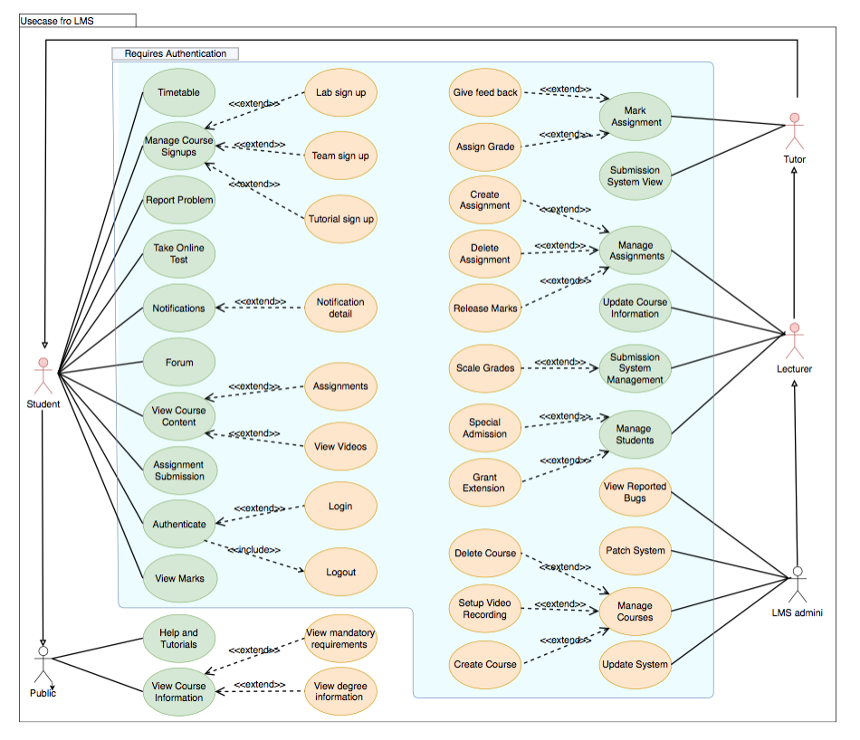

Part 3. Contributions (1 pages)

Hannah Clayton

* Scenarios 1-18
* Personas 1, 2 and 3
* Overview

Meg Hewitt

* Testing

Krishan

* Persona 4

Zequn

* Framework mock ups

Michael

* MIA